**CS5590_Python-MachineLearning - DEEP LEARNING LAB 3**

**Name: DEVENDER SARDA**

**SSO ID: dspc8**

**UMKC Student ID: 16243492**

**Class ID: 45**

***

**Objective**

1. Implement the Text classification with CNN model with new data set which is not used in class

2. Implement the Text classification with RNN model with new data set which is not used in class

3. Implement the Text classification with LSTM model with new data set which is not used in class

4. Compare results of CNN, RNN and LSTM for text classification (same data set for 3 models for comparison) and describe, which model is best for text classification based on your results

**Configuration**

JetBrains PyCharm and Python 3.6.4

**Text Classification with CNN model**

[Task 1 Code Snippet 1]

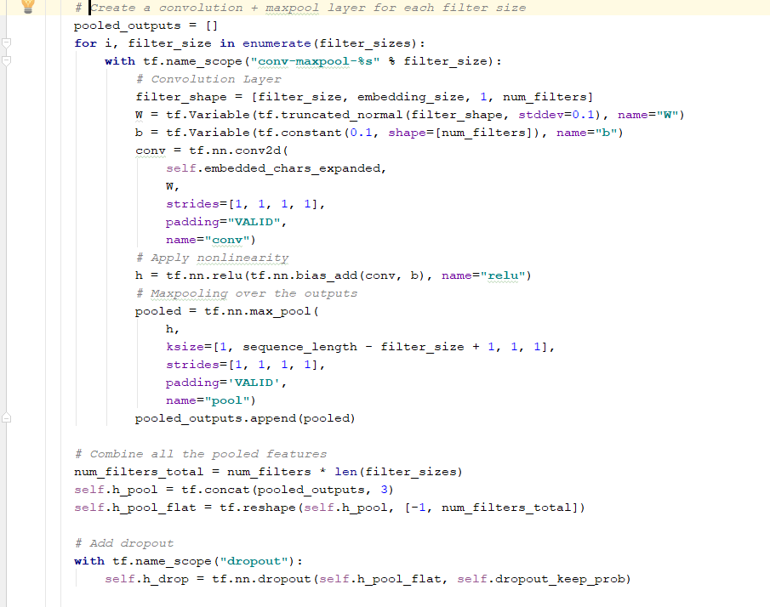

[Task1 - Output]

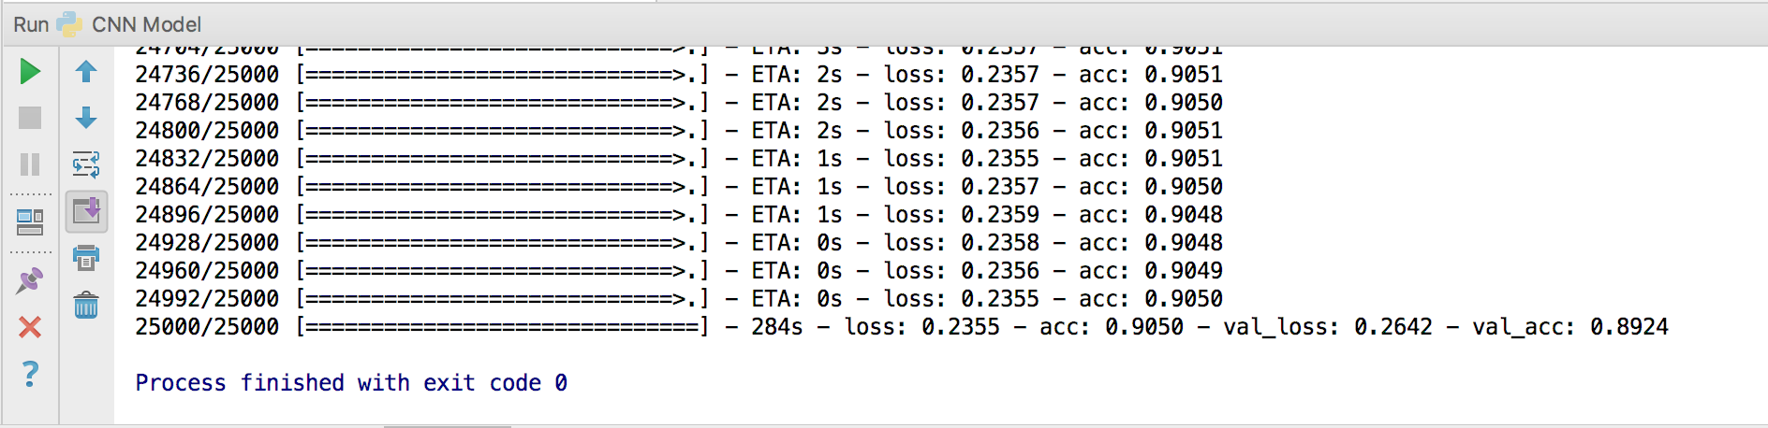

**Text Classification with RNN model**

[Task 2 Code Snippet 1]

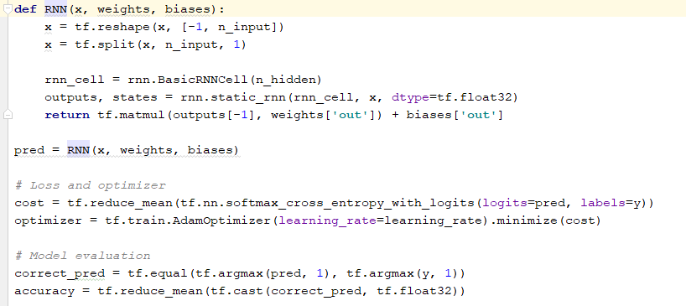

[Task2 – Output]

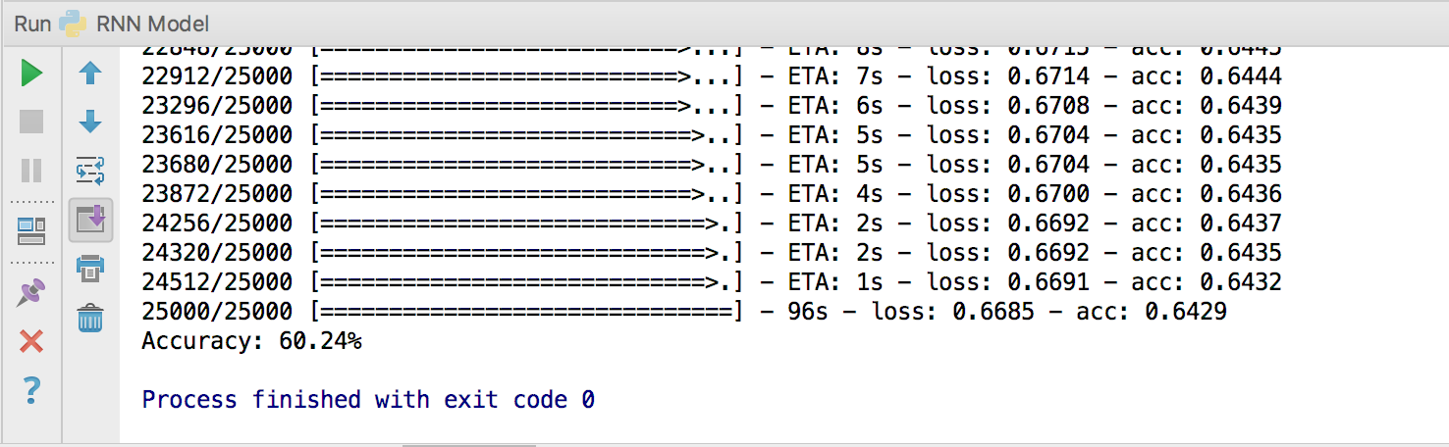

**Text Classification with LSTM model**

[Task 3 Code Snippet 1]

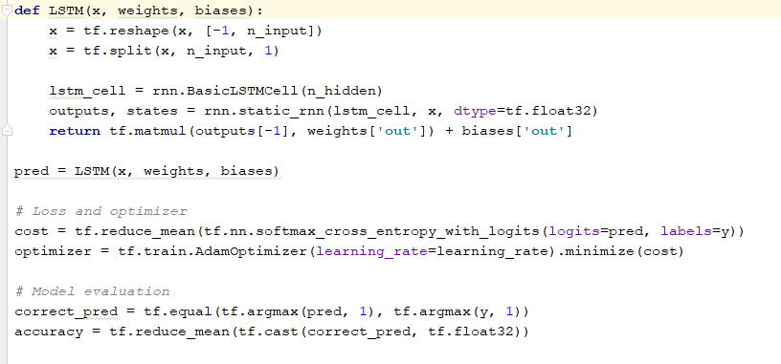

[Task3 – Output]

